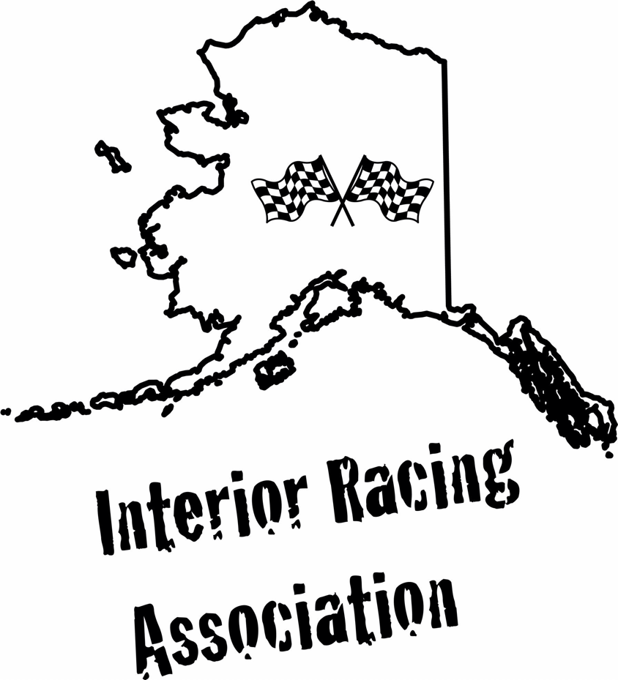

Official Rules and Information For MUD X

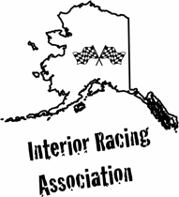
IRA RULEBOOK
As a general rule, unless optional equipment or a modification is specifically permitted by this Rulebook, it is prohibited.

The IRA Rules a re designed to provide for the orderly conduct of the motorsports events and to reduce the risk of injury to both participants and spectators during such events.

It is ultimately the obligation of each participant to ensure that his/her conduct and equipment comply with the applicable IRA rules and regulations, as they may be amended from time to time.

No express or implied warranty of safety shall result from publication, or compliance with, these Rules.

They are intended as a guide for the conduct of the sport and are in no way a guarantee against injury or death to participants, spectators or others.

INTERIOR RACING ASSOCAITION OFFICAL RULES AND INFORMATON

General Vehicle Requirements:

There must be at minimum a 4-point roll cage
The vehicle must be equipped with an operational neutral safety switch.
Vehicle must have rigid front and rear hitching point.
A driver must be able to exit his vehicle in 30 seconds or less.
Each vehicle's battery must be securely held down. (No straps, rope, bungee cords, etc.)
All fuel lines, coolant lines, belts and hoses must be in good condition.
All vehicle must have working and adequate brake systems.
A firewall and full floor is mandatory.
Vehicles must be equipped with a minimum 4-point safety harness for the driver.
Vehicle must be equipped with doors or safety nets adequate to keep the driver’s arms and legs inside the vehicle in the event of a rollover. (Window nets are recommended)
There can be no loose items in the vehicle.
Whenever any vehicle has the engine running there shall be someone in the operator’s seat.
There can be no loose items in the vehicle.
Whenever any vehicle has the engine running there shall be someone in the operator’s seat.
Vehicles with modifications believed to make it unsafe to race will not be allowed to compete. Race Officials with make the final decision.

MAXI M U M SPEED IN PIT AREA IS 5 MPH!!

These rules are made for everyone's safety and will be enforced. Random inspections of vehicles for compliance of the rules may be done at any time during the event.

Event Rules

General Rules fort the Mud X competition

The race entry gate will close 60 Minutes Before the event Starts.

A Mandatory Driver's Meeting will occur 30 minutes before the event starts.

Policy

- No alcohol or drugs permitted. This policy will be strictly enforced and presence of alcohol or drugs will automatically disqualify the driver and vehicle from competition. Any participant who refuses to take a Breathalyzer test, or fails test, will be disqualified immediately by the Tech Inspector.
- The appearance of your vehicle, lettering, graphics, decals, etc. is up to you. However, pictures, wording, etc. should not be offensive and will not be tolerated.
- "Cute" nicknames, slogans, artwork, etc. can be clever, but please do not let your entry become a political statement, for any cause whatsoever.
- In the event of disqualification of vehicle, no refunds will be allowed.
- It is mandatory that a licensed driver be seated in the normal driving position any time the engine is running, including pit area, staging lanes, turn around and return roads.
- No high-speed driving or "hot-dogging" will be tolerated in the Tech or Staging areas. NO WARNING BE GIVEN. These actions are grounds for immediate disqualification of vehicle and driver by Event Management.
- IRA Tech Management has final judgment on any vehicle class. Tech Management has the right to tech any vehicle. Any refusal will be automatic disqualification. IRA has final judgment on all racing decisions.
- You must be 18 years old or older to race in this event.

Driver's Safety:

- A driver must wear a helmet which is full chin and D.O.T. approved.
- Eye protection in the form googles/glasses is required
- No Sandals are allowed. The driver must wear shoes that completely cover the foot must wear long pants a shirt, and gloves. (Fire suit, gloves, face mask, shoulder and helmet restraint, neck collar, and netting are highly recommended.

Note: It is highly recommended that All participants use the following full fire protection: a. SFI approved full-face helmet, b. head sock, c. fire resistant shoes, d. Minimum SFI 3.2A- 1driving suit, e. SFI approved gloves.
General Rules

1. Eligibility

1.1- Each participant agrees to be bound by the rules of IRA and any decision of the Board of Directors, and agrees to voluntarily submit his/her vehicle for inspection or impoundment by IRA to ascertain the legality of the participant’s vehicle.

1.2- Each participant agrees to release and waive IRA from any liability related to the rules of conduct of the motorsports event.

1.3- The IRA Rules are effective upon date of publication by IRA, regardless of when a participant receives actual notice. The current IRA rules are posted on the website: www.interiorracing.org.

1.4- If a participant requires medical attention, by track or other medical personnel, the participant must be released by medical personnel before returning to competition. Failure to comply with advice of medical personnel will result in disqualification.

2. Event Credentials:

2.1- IRA staff or other Pit Control Officials shall retain the authority at all times to remove any person at their discretion.

2 .2- The registration/entry clerks and/or Event Officials have the authority to refuse return of entry/registration fees and to revoke credentials for any participant whom they believe has fraudulently violated the entry/registration procedures.

3. Conduct: Disqualification, Ejection, Fines and Suspension

3 .1- All vehicles must be operated in a safe manner at all times with in the confines of the pit area, staging lanes and track area.

3.2- Participants at IRA events are expected, at all times, to conduct themselves in a professional and non-disruptive manner. Any participant who, in the sole and absolute judgment of IRA 1) verbally or physically threatens another participant, Event Official, or any other person, 2) uses vulgar, abusive or derogatory language, 3) engages in unprofessional and/or unsportsmanlike conduct detrimental to the sport of racing, or 4) causes deliberate delay of the Event, or 5) otherwise creates a condition or circumstances that is unsafe, unfair, or out of order, shall have violated the rules and regulations of IRA, creating just cause for disqualification, and/or ejection from the Event.

3.3- In the event of disqualification of a vehicle, no refunds will be allowed.

3 .4-Violation of these rules is final, non-appealable and non-reviewable. In good cause IRA officials may, without liability, reverse, or revise their decisions.

3.5-The decision of Track Officials shall be final and non-appealable le: provided, however, that with a showing of reasonable and good cause, the Track Official may, without liability, reverse or revise their decisions.

4. Apparel:

4.1- All members of the participant's crew must be properly attired when present in the staging or competition areas. Shoes are mandatory.

4.2- It is highly recommended that ALL participants use the following FULL FIRE PROTECTION: a. head sock, b. fire resistant shoes (no leather boots), minimum SFI 3.2A-1 driving suit, d. SFI approved gloves.

5. Entry/Withdrawal of Vehicle:

5.1- To scratch a vehicle and receive refund of entry fee, the participant is required to notify Tech of their withdrawal 30 minutes prior to the start of the event.
5.2- If the participant doesn't officially scratch prior to the start of the class, the
participant will forfeit his/her entry fee.

6. Staging and Timing:

6.1- A participant must be ready to compete within 5 minutes after being signaled by the Staging Area Officials. Failure to stage upon the Starter's instructions is possible grounds for disqualification.

For Example: Should a competitor take 5 minutes to get to the line and proceed to take another minute to get staged and into position to race, this will result in a disqualification as well.

6.2- It is the participant's responsibility to present his/her vehicle to the staging lanes in the proper running position and be ready to compete when his/her position is reached in the running order. Any deliberate delay will mean disqualification.

Note: However, if the participant makes an effort to compete, every opportunity will be offered them to make their competition appearance.

6.3 No vehicle shall approach the starting line until the signal to compete is given. Failure to follow this rule may result in disqualification.

6.4- Once a vehicle reaches the front of the staging lanes for a run; it must be prepared to fire and race.

6.5- The final staging motion, using applied power, must be in a forward motion, going from pre-stage to stage position.

6.6- One you a re sent to the starting line; be ready to race.

6.7- Any driver leaving the starting line before they are signaled; including a single (bye) run will be disqualified.

6.8- Contact with guard rails, barriers or any other track fixture is grounds for disqualification.

6.9- Intentional crossing of the boundary lines to leave the course to avoid depositing debris on the track, or avoid contact with another vehicle is not grounds for disqualification.

7 Protest Procedures:

7. 1- Participant protest may only be filed by the driver or registered vehicle owner competing in the same event, in the same category as the vehicle being protested.
7.2- Any protest must be made within 30 minutes of class competition.

7.3- The Board of Di rectors shall investigate and decide the protest as promptly as possible and shall inform the parties of the protest of his decision.

7.4- The Board of Directors shall determine the merits of the protest and if the protest is sustained, impose the prescribed penalty or such lesser penalty as he determines appropriate.

7.5- I RA reserves the right to reject any protest filed that it determines, in its sole and absolute discretion, is frivolous or intended to harass another participant or to otherwise gain some unfair competitive advantage.

